DEPARTMENT OF COMPUTER SCIENCE AND ENGINEERING
CSA05-DATABASE MANAGEMENT SYSTEMS
DML Commands – INSERT, SELECT
EXPERIMENT – 3
- Insert faculty table
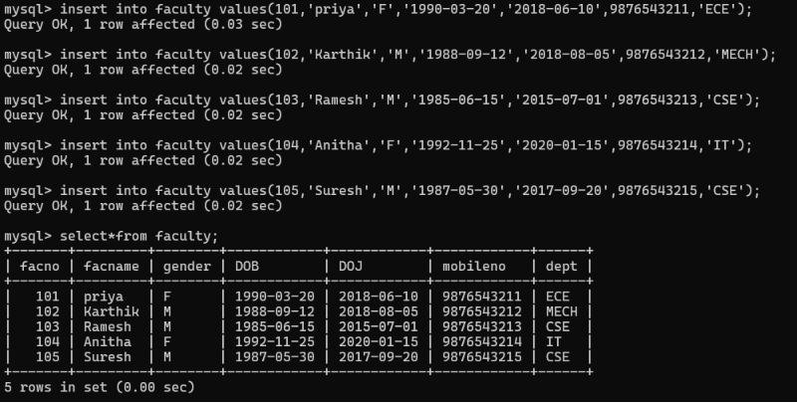

- Insert department table
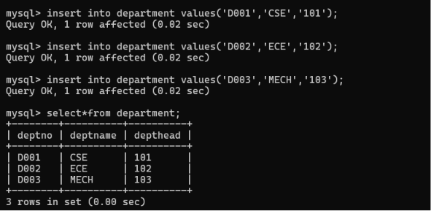

- Insert student table

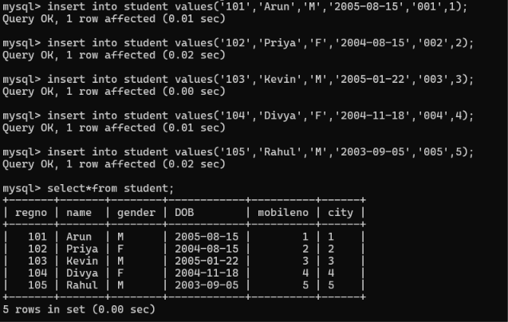

- Insert course table
